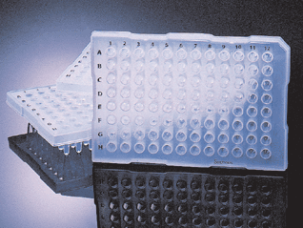

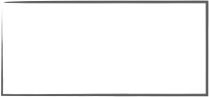
PCR Plate (mini skirt)
This document is located at Desktop/Ardon/Kanban
Reorder information
Quantity
Unit
Vendor
Cat #
Unit price
Tape this card
20
10/pkg

5 left
When you reach this card,
drop it in the technician’s inbox.
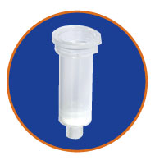

Plasmid miniprep Columns
Reorder information
Quantity
Unit
Vendor
Cat #
Unit price
Tape this card

on last pack
When you reach this card,
drop it in the technician’s inbox.
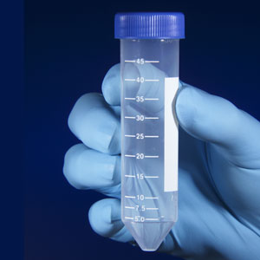
Centrifuge Tubes (50 mL)
Reorder information
Quantity
Unit
Vendor
Cat #
Unit price
Tape this card

on last pack
When you reach this card,
drop it in the technician’s inbox.
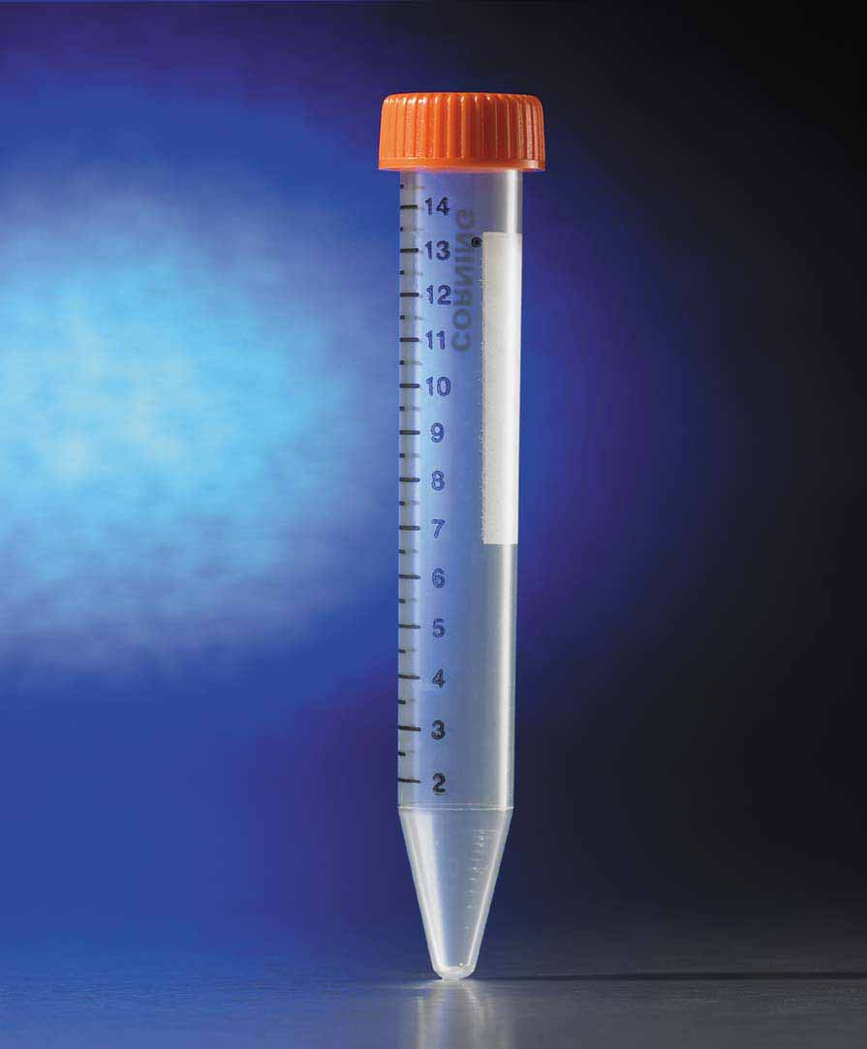

Centrifuge Tubes (15 mL)
Reorder information
Quantity
Unit
Vendor
Cat #
Unit price
Tape this card

on last pack
When you reach this card,
drop it in the technician’s inbox.
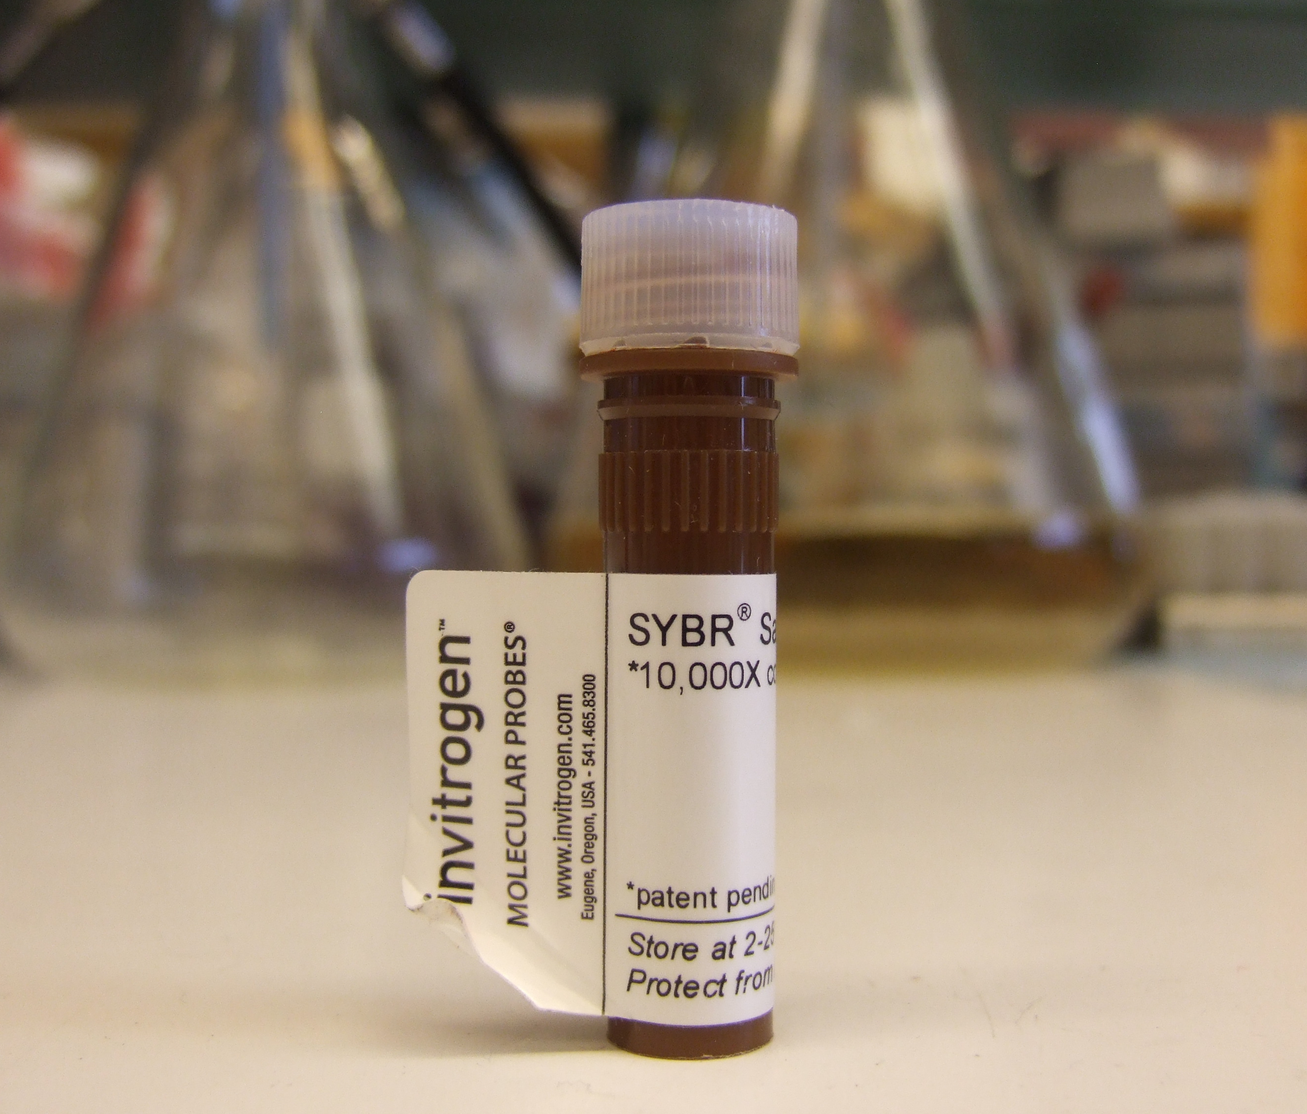

SYBR Safe gel stain
Reorder information
Quantity
Unit
Vendor
Cat #
Unit price
Tape this card
4
ea
invitrogen

on last pack
When you reach this card,
drop it in the technician’s inbox.
10,000x in DMSO
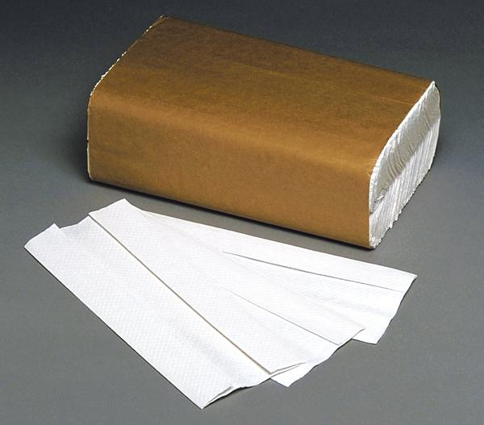

Paper Towels
Reorder information
Quantity
Unit
Vendor
Cat #
Unit price
Insert this card
1
cs
stockroom

3rd to last pack
When you reach this card,
drop it in the technician’s inbox.
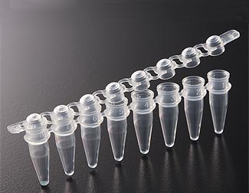
PCR Strips
Reorder information
Quantity
Unit
Vendor
Cat #
Unit price
Insert this card
4
bx

in front of last box
When you reach this card,
drop it in the technician’s inbox.
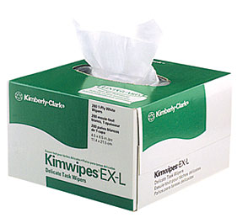

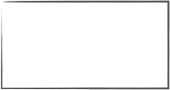
Kimwipes
Reorder information
Quantity
Unit
Vendor
Cat #
Unit price
Total price
Insert this card
10
bx
Stockroom

in front of last box
When you reach this card,
drop it in the technician’s inbox.
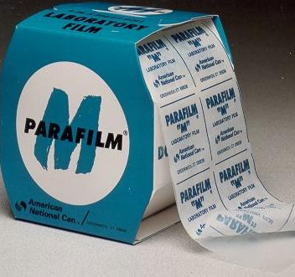
Parafilm
Reorder information
Quantity
Unit
Vendor
Cat #
Unit price
Total price
Insert this card
5
bx
Stockroom

in front of last box
When you reach this card,
drop it in the technician’s inbox.
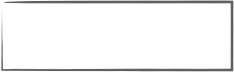
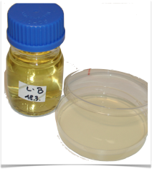
Technician
Quantity to make
Batch size
Aliquot
Insert this card
4—6 L
2 L
500 mL
4 bottles from the end
Lysogeny broth (LB)
When you reach this card,
drop it in the technician’s inbox.
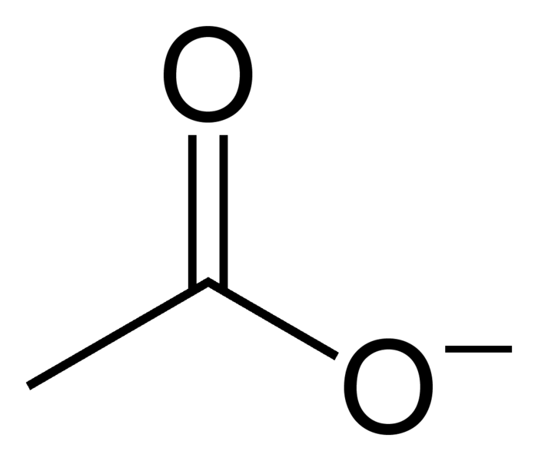
TAE 50x
When you reach this card,
drop it in the technician’s inbox.
tris acetate EDTA electrophoresis buffer
Technician
Quantity to make
Batch size
Aliquot
Insert this card
2 L
2 L
500 mL
2 bottles from the end
Acetate
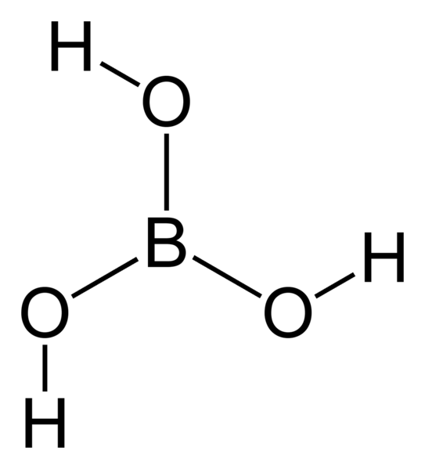
TBE 10x
When you reach this card,
drop it in the technician’s inbox.
tris borate EDTA electrophoresis buffer
Technician
Quantity to make
Batch size
Aliquot
Insert this card
2 L
2 L
500 mL
2 bottles from the end
Boric Acid
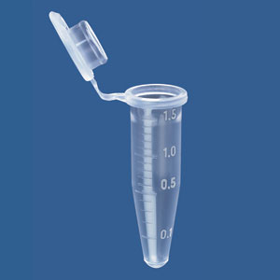
Centrifuge Tubes (1.5 mL)
Reorder information
Quantity
Unit
Vendor
Cat #
Unit price
Total price
Attach this card

on penultimate bag
When you reach this card,
drop it in the technician’s inbox.
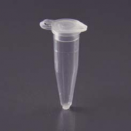

Centrifuge Tubes (0.6 mL)
Reorder information
Quantity
Unit
Vendor
Cat #
Unit price
Attach this card

on penultimate bag
When you reach this card,
drop it in the technician’s inbox.
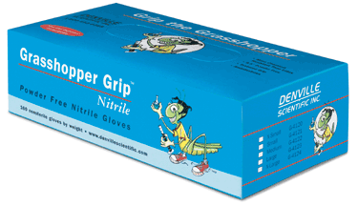

Nitrile Gloves (XS)
Reorder information
Quantity
Unit
Vendor
Cat #
Unit price
Attach this card
1
case of 10 bx

3 boxes left
When you reach this card,
drop it in the technician’s inbox.
Nitrile Gloves (S)
Reorder information
Quantity
Unit
Vendor
Cat #
Unit price
Attach this card

3 boxes left
When you reach this card,
drop it in the technician’s inbox.
Nitrile Gloves (M)
Reorder information
Quantity
Unit
Vendor
Cat #
Unit price
Attach this card

4 boxes left
When you reach this card,
drop it in the technician’s inbox.
Nitrile Gloves (L)
Reorder information
Quantity
Unit
Vendor
Cat #
Unit price
Attach this card

3 boxes left
When you reach this card,
drop it in the technician’s inbox.
Nitrile Gloves (XL)
Reorder information
Quantity
Unit
Vendor
Cat #
Unit price
Attach this card

3 boxes left
When you reach this card,
drop it in the technician’s inbox.
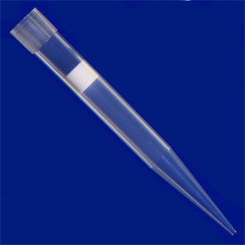

Barrier Tips: 1000 mcL
Reorder information
Quantity
Unit
Vendor
Cat #
Unit price
Attach this card

last pack
When you reach this card,
drop it in the technician’s inbox.

Barrier Tips: 200 mcL
Reorder information
Quantity
Unit
Vendor
Cat #
Unit price
Attach this card

last pack
When you reach this card,
drop it in the technician’s inbox.
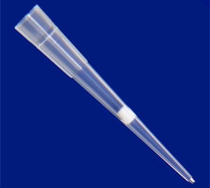

Barrier Tips: 20 mcL
Reorder information
Quantity
Unit
Vendor
Cat #
Unit price
Attach this card

last pack
When you reach this card,
drop it in the technician’s inbox.
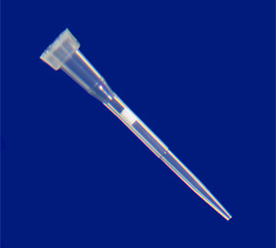
Barrier Tips: 10 mcL
Reorder information
Quantity
Unit
Vendor
Cat #
Unit price
Attach this card

last pack
When you reach this card,
drop it in the technician’s inbox.

